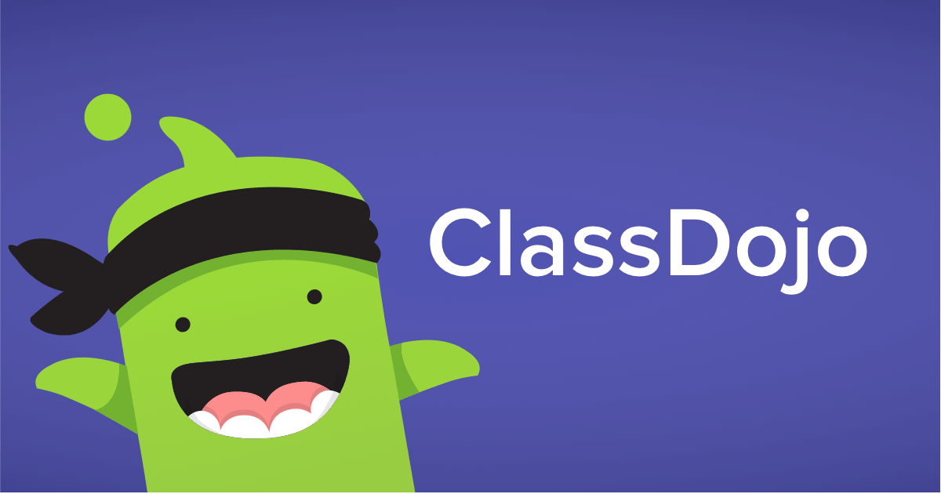**NESD Class Dojo**

**Basics:**

* All part of “NESD Head Start” School
* Teachers/Home Visitors each have 1 classroom
* “Co-Teachers” on each classroom = teacher assistant (optional), EC, FSC, Kristie, Jessica, and Juli

**Uses:**

Required:

* As a Communication Tool
  + Classroom Story
  + School Story (EC, FSC, Kristie, Jessica, Juli can also post to all school story)
  + Messaging (entire classroom or one parent)
  + Translation (parents setting on their end)
  + Turn Off Points View for Families
  + No Student Accounts – parents can share to portfolios through their account, if wanted

Optional (some form of these may use more in the future):

* Portfolios
* Create your own activities
* Instant Feedback (points system)
* SEL Videos and Activities (classroom orientated)
* Toolkit (for classroom use)
* “Worksheets” option – while we don’t use “worksheets” in ECE, could use for in-kind, etc.

**Throughout the Year:**

|  |
| --- |
| **Beginning of Year: (or when new students start)** |
| 1. Parent Packet – Parent Invite Letter (info on signing them up) 2. Add Students to your classroom 3. Delete any past students that are no longer in your classroom 4. Invite Parents by entering their email/cell phone (or send home class code) 5. Post a Beginning of the Year Welcome Post |
| **Throughout the Year:** |
| 1. Use Classroom Story to post updates from the classroom, upcoming events, reminders, etc. 2. Use individual or group messages to contact individual parents, groups of parents 3. (Optional) – use Portfolios to get information back from parents on in-kind, at-home activities, etc. |
| **End of the Year:** |
| 1. Post and “End of Year Post” to let parents know it’s the last contact 2. Individually delete children moving on to Kindergarten |

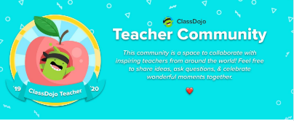**Resources:**

ClassDojo Teacher Community on Facebook:

ClassDojo YouTube Channel: <https://www.youtube.com/channel/UCxgOUb7t6VTS0-TPSPInBpg>

ClassDojo Helpdesk: <https://classdojo.zendesk.com/hc/en-us>